Potentiality of Power Production From Gebit Alsharaf Dam, Red Sea State, Sudan

Moataz Abdelgadir¹ , Obai Younis Taha² and Osama Mohammed Elmardi³
¹Red Sea University,Faculty of Engineering,Mechanical Engineering Department, Sudan

²University of Khartoum, Faculty of engineering,Mechanical Engineering Department, Sudan
¹Nile Valley University,Faculty of Engineering,Mechanical Engineering Department, Sudan

Abstract. The purpose of this research is to study the possibility of using water power to drive a hydraulic turbine installed in the drinking water pipeline emerging from a dam. The dam is constructed in the Red Sea state by the Dams Implementation Unit Kaleidoscope to solve water supply problem by harvesting and storing rainwater. In this study the required data is collected from the site of the dam and analyzed in terms of hydrological and topographic studies. Using this data the flow rate of water through the pipe is estimated by applying the energy equation using Excel program analysis. Given flow rate and available head, the power is calculated and found to be about 19.39 kW. Suitable turbine and generator is selected. Finally, the results are compared with those obtained when using the program (Hydro Help - CLOVA issue, January 2010) and found to give very close agreements.
Nomenclature

DIU Dam Implementation Unit
MHS Micro Hydropower System
MHP Micro Hydropower Project
DC Direct Currant
SHP Small Hydro Power
AC Alternately Currant
HDPE High Density Polythene
m Meter
m3 Meter Cube
Km Kilo Meter
Sq Square
f Friction factor
L Length of the Pipe
D Pipe diameter
v Average Velocity
g Gravitational Acceleration
P Power
H Head
Q Water Flow Rate
ρ Density
η Overall Efficiency
MW Mega Watt
h Hour
N_{R} Reynolds Number
Inroduction
Sudan is the one of the largest country in Africa, the country extends gradually from the desert in the north, with its hot dry climate and almost no vegetation cover, to the African Sahel zone in the center (dry to semi-dry climate) with its light and dense savannah, to the sub-tropical region in the south with heavier rains and dense tree cover. In terms of rainfall, Sudan is one of the driest but also the most variable country. Extreme years (either good or bad) are more common than average years. The majority of agricultural activities depends on rainfall, which is erratic and varies significantly from the north to the south of the country. In many parts of the country people suffering from water shortages and scarcity.Therefore they are forced to drink with their animals from ponds because it is less expensive. The unreliable nature of the rainfall, together with its concentration into short growing seasons, heightens the vulnerability of Sudan’s rain fed agricultural systems as well as drinking water in many areas like Red Sea State. Over the last century, the Red Sea State has experienced, at least, fourteen cycles of drought, which affected its livelihood system. Highly complex concerts of factors, both natural and induced have combined to create a situation of structural poverty. The economic potential of the Red Sea Region appears to be quite favorable but hinges on the sustainable availability of usable water. Government of Sudan has planned to implement an integrated program for water harvesting, particularly for relief in shortage of water supply to people and livestock in Red Sea state. Therefore, a number of convergent projects are planned to build across the state for storing and harvesting rainfall runoff. Gebit Alsharaf Dam is among those projects. It has been planned to be constructed near Sinkat area in the Red sea state, for sustainable drinking water storage. Gebit Alsharaf Dam Project is located Upstream of Sinkat Town, on Gebit Khor locally known as Khor Yuyetb, to address the water supply needs of the people and livestock of the area. Gebit Khor is a non-perennial stream that collects run off from its drainage basin during the rainy season which extends from August to November. The rain fall in the area is very low, the runoff flows away due to the lack of necessary storage areas. Therefore, water availability for the local people and their livestock is insufficient and the existing facilities for water supply and distribution show serious deficiencies. In general, the demand for water exceeds its availability and the overall situation of the city is characterized by regular shortages, which result in bad environmental conditions. The problem is increasing from day to day due to increasing demands. Dam Implementation Unit of the Federal Ministry of Water Resources and Electricity is undertaking water harvesting projects to supplement water supply to the people and livestock. DIU commissioned Shoura Consult Company and AGES Consultants Pakistan for design and implementation of the water harvesting projects. The goal of development is socio-economic enhancement of the local communities through: • Establishment of water storage reservoir along the Gebit Khor.
• Enhance water availability and reliability for drinking and farming.
Drinking outlet works are required to release the water impounded in a reservoir for drinking purpose. At Gebit dam Project the main purpose of the outlet works is to deliver water supplies downstream of the dam to provide drinking water to the downstream area. The same outlet works should also be used for diversion of river supplies (municipal supplies) during the construction of the dam. This can also be used for regulation of minor flood flows. Engineering Consultancy Center and Water Corporation in Red Sea State designed the drinking water pipe from Gebit Alsharaf dam to Sinkat and Gebit towns as shown in Figure (1) and (2). [Red Sea Engineering Consultancy Center].
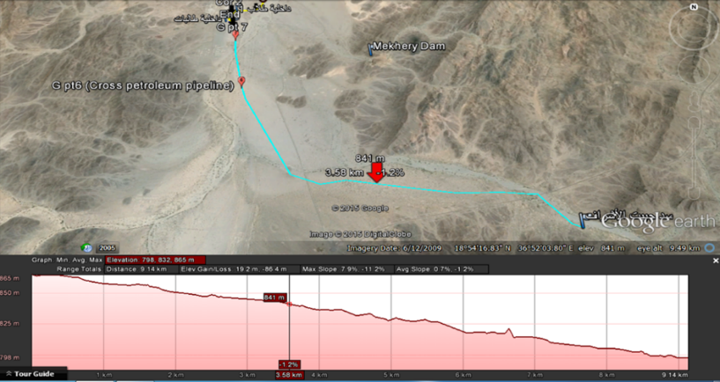
Figure (1) Water Pipeline from Gebit Dam to Gebit Town
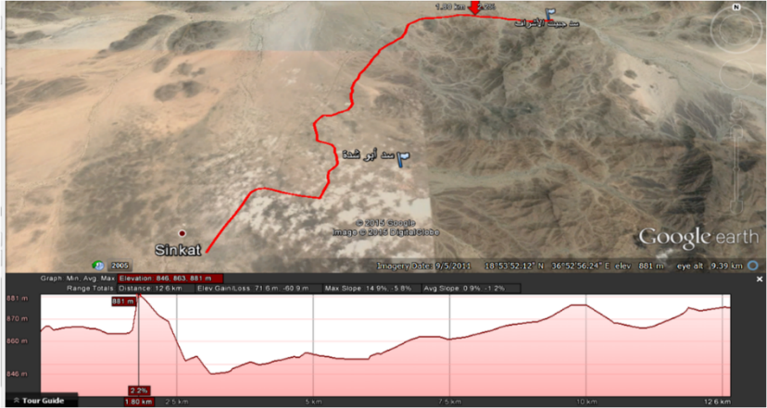
Figure (2) Water Pipeline from Gebit Dam to Sinkat Town
The water pipeline from Gebit dam to Sinkat town Figure (2) needs some pumps for pumping more water. Therefore, the pipeline must be connected to the pipeline coming from Aposhedh dam so that it can feed Sinkat town [Red Sea Engineering Consultancy Center]. But water pipeline from Gebit dam to Gebit town which is shown in Figure (1) is almost straight and and there is enough gradient head that takes water flow to Gebit town by gravity.
Objectives
The main objective of this study is to study the possibility of the potential of hydro power for the establishing hydraulic turbine in the line of water pipes, in Gebit Alsharaf Dam in order to convert the available energy of water into electrical energy.
Limitations of the Study
The study is limited in several fronts. Firstly, the focus of the study is on Micro Hydropower System(MHS) rather than small, medium or large hydropower plant (HPP). Each of which requires totally different approach to system design. Secondly, although the investment and design of MHS is oriented primarily for generation of electricity for consumption, the study focuses only on the technical specification and design of MHS rather than designing network for electricity distribution which in turn requires a totally different perspective in system design. Thirdly, the actual implementation process of MHS is inevitably affected by the local political, legal, social and economic environment, which are not the focus of this study; rather it is concerned mainly with the technical design and implementation of the dam. Also, the choice of components and geography are limited by financial considerations, although they might not be implemented with a strict financial rationale. Therefore, consideration of financial factors in choice of components and geography are omitted from this study.
Hydro Power Project Classification
Hydro power projects are generally categorized in two segments i.e. small and large hydro. Different countries are following different norms keeping the upper limit of small hydro ranging from 5 to 50 MW. However, there is no consensus on the definition of small hydropower. Some countries like Portugal, Spain, Ireland, Greece and Belgium, accept 10 MW as the upper limit for installed capacity. In
Italy the limit is fixed at 3 MW (plants with larger installed power should sell their electricity at lower prices) and in Sweden 1.5 MW. In France the limit has been recently established at 12 MW, not as an explicit limit of medium hydropower (MHP), but as the maximum value of installed power for which the grid has the obligation to buy electricity from renewable energy sources [1]. In the UK 20MW is generally accepted as the 5 threshold for small hydro. Though different countries have different criteria to classify hydro power plants, a general classification of hydro power plants is shown in Table (1) below.
Table (1) Hydro Power Project Classification

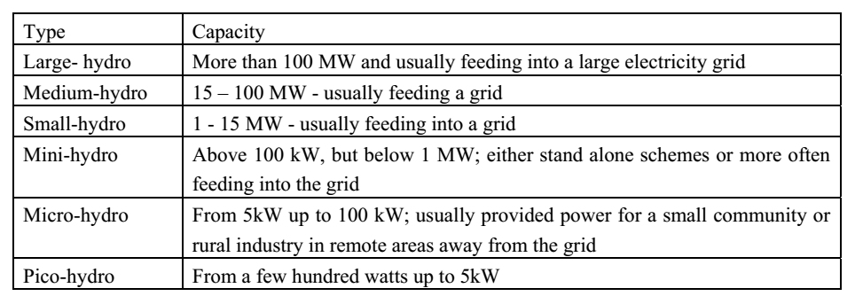
Methodology
A micro turbine is a wonderful way to generate you own electricity because it is so ecologically friendly[2]. It has little or no impact on the environment and will provide continuous energy year round at low cost. Unfortunately, not many of us can access this resource since it usually requires a large track of land with a stream. For those of us who live in the countryside, it is possible that you could have a stream nearby on public land that you could access. In this case it may require a longer line (or penstock) to get the water from its source to your land where you will put your micro turbine. This paper is about how you can figure out how much energy will be available considering your terrain and water availability. Generally, there are two types of micro hydro system, flow of stream and storage type. However, in this paper, the system is based on storage type. A micro hydro system converts the potential energy of water into electricity by the use of flowing water. This water flows in water streams with different slopes giving rise to different potential for creating heads. The capacity of power is dependent on the head and flow rate as shown in Figure (3).
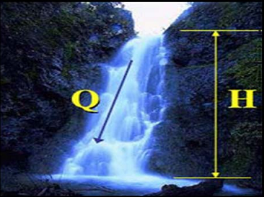
Figure (3) the Head and Water Flow Rate
Head
The head, H (in meters) is the vertical height difference between where the water would enter the intake pipeline or penstock and turbine. Hydro sites can be categorized according to the available head for hydro system, the greatest fall over the shortest distance is preferable when choosing a hydro site. However, more head is usually preferable since power is the product of head and flow. So, less flow is required at a higher head to generate similar amounts of power. With a higher head, the turbine is able to run at a higher speed. If a high head is available, a smaller turbine and generator might be necessary for the same flow and the water conveyance system can also be smaller and thus less costly.
Water Flow Rate
The water volume is simply measured as the flow rate, Q (in cubic meters per second) of the water which is usually limited by the size of the stream. The larger the stream the more water is available for a hydro development. However, not all the water can be diverted from a river for use in power production, as water must remain in the river for environmental reasons. Nevertheless, other solutions are possible where no water is diverted such as storage type micro hydro system.
Power Generation
In micro hydro system, there are two factors which determine the power potential of the water flowing in a stream i.e. flow and head .The potential power can be determined as:
P = g × ρ × Q × H (1)
This potential energy will turn into kinetic energy when the water falls down over the head through the pipeline. This kinetic energy is kind of pressure which will rotate the shaft of hydraulic turbine. Mechanical energy from turbine then will drive synchronous generator to produce electricity in term of alternating current (AC). The electricity will then be distributed to residencial, commercial and industrial complexes. The AC power supply must be maintained at a constant 50 or 60 cycles/second for the reliable operation of any electrical equipment using the supply. This frequency is determined by the speed of the turbine which must be very accurately governed.
Results And Discussions
Based on the field survey data, the study dealt with designing the major civil components for the Gebit Dam project [3]. Based on the design parameters, the calculations carried out helped to determine the Powerhouse components of the Micro Hydro Project. The various components are summarized in Table (2)
Table (2) Survey Data
878.5m | Crest of Dam
877 m | Normal water level
868 m | invert elevation of Bottom outlet
0.30 m | Diameter of outlet pipe
9 m | Effective head from center of outlet
9200 m | Total length of pipe

Head Measurement
Normal water level= Crest of Dam - 1.5
= 878.5 - 1.5= 877 m
Effective head from center of outlet = 877 - 868 = 9 m
Static head = Effective head+ pipe elevation
= 9+67 = 76 m
Selection of Penstock
The optimal pipe size and material of the penstock was calculated from the Engineering Consultancy center and Water Corporation in Red Sea State. The results lead to selection of High Density Polythene pipe (HDPE).
Estimated Water Flow Rate
From equation (2) the maximum flow in the penstock is calculated, by appling the energy equation and substituting the turbine head equal zero (i.e. without turbine) we get:
$$76=\frac{fl}{d}\frac{v^{2}}{2g}+\frac{v^{2}}{2g}+\left(H_{t}=0\right) (2)$$
$$76=\frac{fl}{d}\frac{v^{2}}{2g}+\frac{v^{2}}{2g} (3)$$
Equation (3) is solved by iteration methods and using excel program, we get.
$$v=1.9446\frac{m}{s} Q=0.1374534\frac{m^{3}}{s}$$

Calculated Potential Power
The flow rate is reduced to determine the turbine head existing by using excel program. The maximum head is found at the minimum flow rate which is shown in Figure (4) below.

Figure (4) the Turbine Head Vs Flow Rate
Moreover that the flow rate is reduced to know the power existing in the turbine by using excel program. It is found that, the power existing is increased when the flow rate is decreased up to the maximum and then is decreased shown in Figure (5) below.

Figure (5) the power Vs Flow Rate
For the different static head the turbine head and power existing is calculated as shown in Table (3).

Table (3) Turbine Head and Power for the Different Static Head

Static head (m) | Maximum flow rate  (m3/s) | Design flow rate  (m3/s) | turbine head  (m) | Power  (kw)
76 | 0.1374534 | 0.0824720 | 46.074 | 37.276
75 | 0.1364619 | 0.0815466 | 45.682 | 36.544
74 | 0.1354643 | 0.0808795 | 45.117 | 35.797
73 | 0.1344604 | 0.0798756 | 44.765 | 35.077
72 | 0.1334503 | 0.0788655 | 44.411 | 34.360
71 | 0.1324336 | 0.0778488 | 44.055 | 33.644
70 | 0.1314104 | 0.0768256 | 43.695 | 32.931
69 | 0.1303804 | 0.0757956 | 43.333 | 32.220
68 | 0.1293436 | 0.0747588 | 42.967 | 31.511

Turbine Selection and Efficiency
In a MHS system, the hydraulic turbine is the primary component which converts the energy of the flowing water into mechanical energy through the rotation of runners. The choice of particular turbine depends upon technical parameters such as design head and discharge at which the turbine is to operate, as well as other practical considerations such as the availability and cost of maintenance personnel. The optimum speed of the turbine is the particular speed of its rotor at which the turbine performs its best performance. The turbine needs to operate at this optimum speed in order to get maximum possible output at all loading conditions.The suitable turbine is selected by considering the turbines' type field of application chart [4] which is shown in Figure (6) and also could be found by using (Hydro Help - Turbine selection - CLOVA issue, January 2010 ) ,the suitable turbine is Turgo turbine which is shown in Figure (7) . It is found that the result is similar when using the two methods.
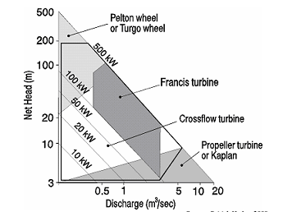
Figure (6) Turbines' Type Field of Application
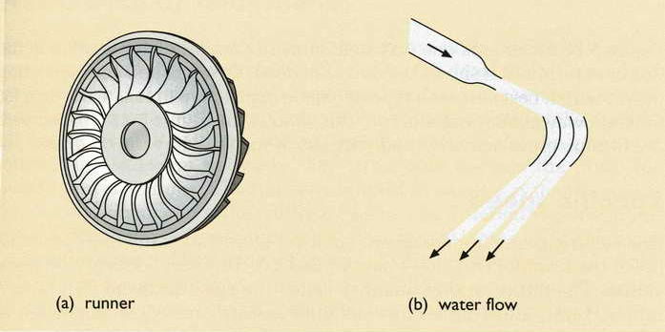
Figure (7) Turgo Turbine: (a) runner; (b) water flow
Typical efficiency variation range of turbines and water wheels are given in Table (4) below. For more precise figures, turbine manufacturers should be consaulted. Turbines are chosen or are sometimes tailor-made according to site conditions. Selecting the right turbine is one of the most important parts of designing a micro-hydropower system, and the skills of an engineer are needed in order to choose the most effective turbine for a site, taking into consideration cost, variations in head, variations in flow, the amount of sediment in the water and overall efficiency [5].Typical efficiency ranges of Turgo turbine by referring to Table (4) was found to be (80-95) %.
Table (4) Variation Efficiency Ranges of Turbines
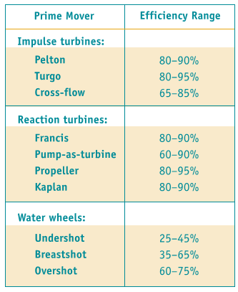

For the minimum value of the efficiency we get:
The power existing from turbine = 37.3*0.8= 29.84 kw
The Generator Selection and Efficiency
Induction generator is the suitable type of generators in MHP (Micro Hydro Project) because they can operate at variable speeds with constant frequency, they are available and cheap and requires less maintenance than the synchronous generators.The efficiency of induction generators is approximately 65 percent at part load [6].
The power existing from generator =29.84*0.65=19.39kw
Also method (Hydro Help - Turbine selection - CLOVA issue, January 2010) was used to calculate the power existing from generator, and it gave the same result.
Selection of the Turbine Location
The turbine could be constructed in different locations on the penstock by neglecting the exit pressure from the turbine, the maximum power existing in maximum static head is shown in Table (5). In conclusion if a maximum power is needed, than the turbine must be located near Gebeit town, otherwise the power is reduced.
Flowrate (m3/s) | static head (m) | pipe dia (mm) | pipe length (m) | Turbine Head (Ht) | power (kw)
0.0733085 | 9 | 300 | 60 | 8.788 | 6.320
0.0733085 | 24 | 300 | 1060 | 21.168 | 15.223
0.0733085 | 33 | 300 | 3580 | 23.566 | 16.948
0.0733085 | 49 | 300 | 5060 | 35.689 | 25.666
0.0733085 | 76 | 300 | 9200 | 51.843 | 37.283
Table (5) Turbine power in the Different Locations

The average energy produced per year and the average flow rate per year of the turbine are shown in Table (6), it is observed that in 21 hours the flow rate becomes greater than the storage capacity of the dam, which means the operation time between (1-20) hours per day is suitable.
Table (6) Energy and Flow Rate produced in Hour per Year
Time (h/day) | Energy (Mwh)/year | flow rate (m3/year) | Time  (h/day) | Energy (Mwh)/year | flow rate (m3/year)
1 | 12.55 | 103495 | 13 | 163.15 | 1345431
2 | 25.10 | 206989 | 14 | 175.70 | 1448926
3 | 37.65 | 310484 | 15 | 188.25 | 1552421
4 | 50.20 | 413979 | 16 | 200.80 | 1655915
5 | 62.75 | 517474 | 17 | 213.35 | 1759410
6 | 75.30 | 620968 | 18 | 225.90 | 1862905
7 | 87.85 | 724463 | 19 | 238.45 | 1966399
8 | 100.40 | 827958 | 20 | 251.00 | 2069894
9 | 112.95 | 931452 | 21 | 263.55 | 2173389
10 | 125.50 | 1034947 | 22 | 276.10 | 2276883
11 | 138.05 | 1138442 | 23 | 288.65 | 2380378
12 | 150.60 | 1241936 | 24 | 301.20 | 2483873
Therefore, the suitable operation time must be ranged between (1-20) hours per day. These results must be corrected if the losses of Interception, Evaporation, Transpiration Evapotranspiration, Infiltration and Watershed leakage are neglected.
Conclusions
Hydropower is a clean source of energy. The water being stored contains potential energy due to its height i.e. head. This potential energy is converted into kinetic energy due to gravity and then supplied to the required places. The potential energy goes unutilized. It can be used to obtain useful work for generation of energy, this makes effective utilization of potential energy that would otherwise wasted. This paper presents an overview of using the potential of hydro power from the Gebit Alsharaf Dam in eastern Sudan to generate micro hydro electrical power. Some of the main points and conclusions are summarized below:
1- Review the study and detailed engineering design of the dam.
2- Measuring head and Water Flow Rate.
3- Use of flow water in overhead dam to generate electricity power.
4- The power is calculated and found to be about 19.39 Kw
5- The better turbine selected for this case is Turgo turbine and Typical efficiency ranges of Turgo turbine is (80-95) %.
6- The settable type of generators in MHP Induction generators and the approximate efficiency is 65 percent at part load.
7- To get the maximum power the turbine must be located near Gebit Alsharaf town.
8- The maximum operation time should be less than 20 hour per day (if we ignore the losses of Interception, Evaporation, Transpiration Evapotranspiration, Infiltration and Watershed leakage).
9- The results is compared by using (Hydro Help – Turbine selection - CLOVA issue, January 2010) and the results are found to be very close.

References
- Dilip Singh, September 2009, Micro Hydro Power Resource Assessment Handbook, Asian and Pacific Centre for Transfer of Technology Of the United Nations – Economic (APCTT) and Social Commission for Asia and the Pacific (ESCAP).
- Noor Azliza BT Ibrahim, July 2012, Modelling Of Micro Hydroelectric System Design, degree of Master of Electrical Engineering, University Tun Hussein Onn Malaysia.
- Shoura Consult Company Ltd, February 2014, Gebit Alsharaf Dam Rehabilitation “Final Design Report –Volume 1F”, Dams Implementation Unit (DIU).
- Jane Wickham, January 2010, Reclaiming Lost Power – Kilkenny’s Potential Hydro Power Sites, Carlow Kilkenny Energy Agency.
- Josée Bonhomme, Robert Clark, Scott Davis and Stephen Graham, 2004,Hydraulic Energy Program, Renewable Energy Technology Program, CANMET Energy Technology Centre (CETC) in cooperation with the Renewable and Electrical Energy Division (REED), Electricity Resources Branch, Natural Resources Canada (NRCan).
- Anil Kunwor, 2012, Technical Specifications of Micro Hydropower System Design and its Implementation Feasibility Analysis and Design of Lamaya Khola Micro Hydro Power Plant, Bachelor’s Degree Thesis Industrial Management.

